Karltech LPT Cape
User's Guide

Table of Contents:

Overview:

The Karltech LPT Cape provides a pair of x86 like parallel port interfaces to the BeagleBone and BeagleBone Black single board computers. These LPT ports have a nearly identical memory mapped interface to x86 hardware facilitating the porting of old applications to the very small bone. The external interface is also almost identical to x86, supporting true 5 volt operation and bidirectional modes limiting compatibility problems.
The cape is in a standard cape form factor which fits on to the top of the bone in only one way. There are 3 connector facing the top side of the board. These are J3,J4 and J6. J6 is a JTAG connector that can be used to load custom firmware on the FPGA. J3,J4 are IDC26 connectors. This is a standard connector used on PC motherboards which have parallel ports which are mounted to the case.

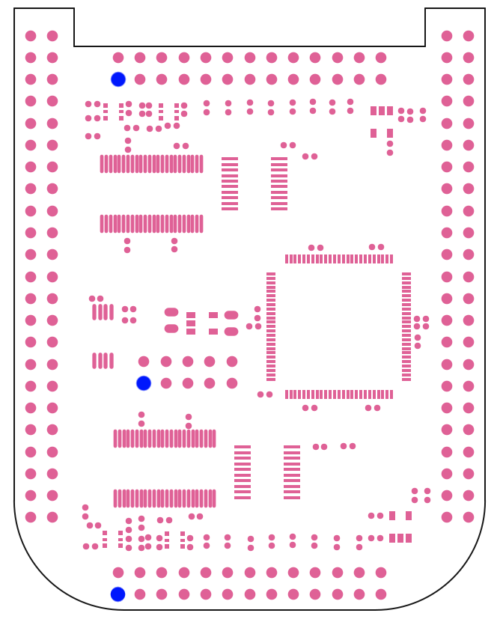

J4

J6

J3

Figure 1. Cape component layout. Blue dot denotes pin 1.

Installation:

Insert the cape into the bone or any capes that will reside beneath the LPT cape. LPT cape has a fixed I2C address for it's EEPROM. If installing with other capes, set the dip switches to any address other than “11”.
If you are connecting to hardware with DB25 connectors you will need adapters. These are referred to as “IDC26 DB25” cables. They can be found on amazon/ebay or are available from Karltech. The adapter must be attached to the cape so that the red line on the ribbon cable lines is on the same side as pin 1 for the connector you are using.

Software:

Software is available from https://github.com/jonpry/LPT Sd-card images coming soon. If you want to use the cape with standard printers and scanners, you will need either an sd-card image or to apply the kernel patch in the git repo.

Non-Printer usage:

Beaglebone requires that device tree overlays be loaded for any installed capes. The file dtbs/BB-BONE-LPT-00A0.dtbo must be copied into your /lib/firmware directory. Depending on the distribution you are running this may load automatically on reboot. Debian distros seem to have trouble with this.
You can check to see if your distribution is loading automatically by searching dmesg for a line like:

bone-capemgr bone_capemgr.9: loader: failed to load slot-3 BB-BONE-LPT:00A0 (prio 0)

If you are getting this, then execute the following command:

echo BB-BONE-LPT > /sys/devices/bone_capemgr.9/slots

This command will have to be run every boot and can be added to a startup script.

The software package includes a program called “gpmc_tool”, running gpmc_tool sets up the gpmc controller in the CPU. After running gpmc tool it is possible for other software and even kernel drivers to access the parallel port as a memory mapped peripheral. This can also be added to a startup script.

Custom applications are able to link with the provided gpmc.c and header files. These provide some utility functions for memory mapping the ports from userspace and provide defines for the registers. If you are only using a custom application, running gpmc_tool is not necessary because the gpmc.c code is capable of initializing the port.

Connector Pinouts:

J3,J4

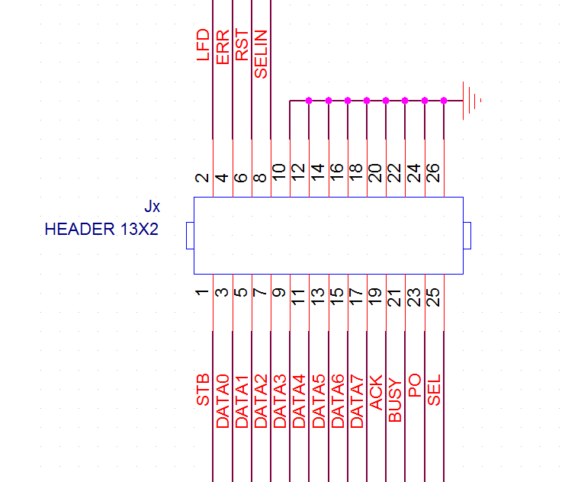

J6

